Fitchburg Urban Forest Planning Community Survey

We need you to be heard about your experiences and opinions with trees and green spaces in Fitchburg. This will enlighten the Fitchburg Parks, Recreation and Forestry Department about your desire for the future urban forest. The survey should take about 10 minutes of your time. Share your story by August 15, 2025 through the printed survey, direct HTTP link or QR code for the language version you prefer. (Note Survey Was Extended to September 15th)

English Version Link: https://forms.office.com/r/W25w0rJBi5

Spanish Version Link: https://forms.office.com/r/Un32e2RqKW






Spanish Version QR Code

English Version QR Code
Your response is vital to help develop the Fitchburg Strategic Urban Forestry Management Plan for the future. This will also help us update our 2015 Fitchburg Urban Forest Survey Results (https://www.fitchburgwi.gov/636/Urban-Forestry). We thank you in advance for your insight.

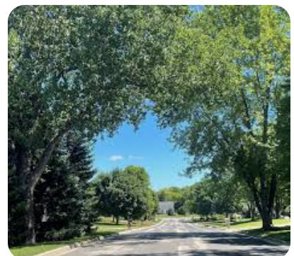
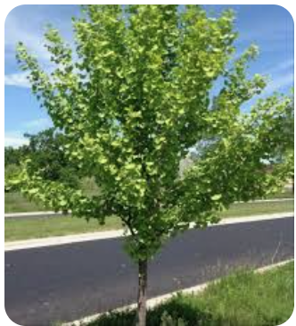
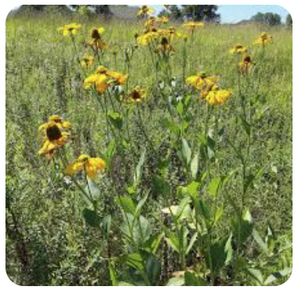
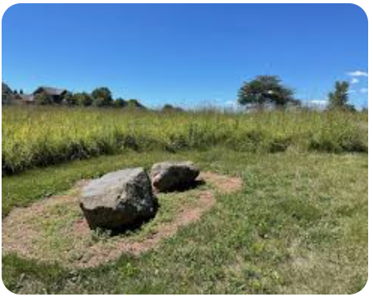


Project Purpose
The “Moving Fitchburg Forestry Forward” project end-point is a strategic urban forestry management plan by the end of the year. The plan will outline what urban forestry resources the City of Fitchburg currently has, identify goals and objectives for the urban forestry program, and create a plan on how to accomplish these goals and objectives. The plan must be vertically integrated with relevant City of Fitchburg plans and policies such as The City of Fitchburg Parks and Open Space Plan, The City of Fitchburg Comprehensive Plan, The City of Fitchburg Mission, Vision, and Values, and the Forest Management Plan for McGaw Community Park. An important part is understanding the City of Fitchburg’s capacity to manage and retain urban tree canopy on public and private property.

Instructions

Please provide your best response to the following questions. You response is anonymous and will be summarized as a part of all responses. Read each question and answer as specified. There are three sections Experience with Trees, Management of Trees, and Demographic Information.

Experience with Trees

- Having trees in my community or neighborhood is _______. (select one choice) (n=364, Mean Index Score = 4.8)

Ranking | Number | Percent
Not important (1) | 1 | 0.3
Somewhat important (2) | 1 | 0.3
Moderately important (3) | 10 | 2.7
Very Important (4) | 55 | 15.1
Extremely Important (5) | 297 | 81.6
Totals | 364 | 100

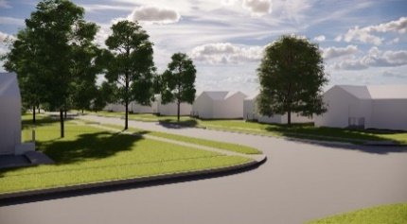
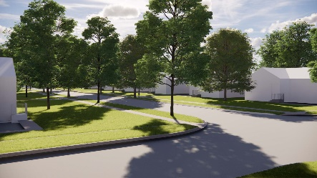
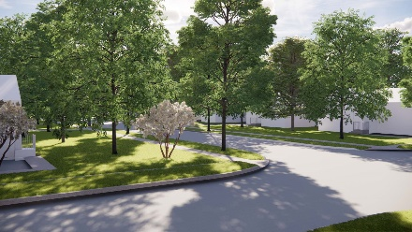
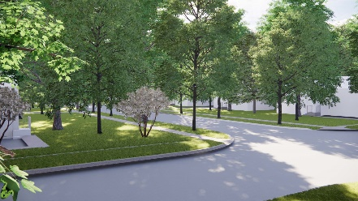
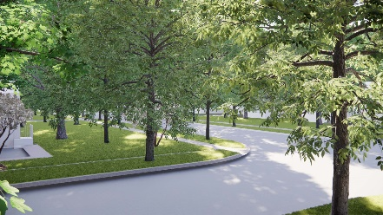
- Which of the following images (letter) best represents the tree cover/shade in your neighborhood? (n=364)
(A)
(B)
(C)
(D)
(E)

My neighborhood doesn’t have trees.
(F)

Circle the letter represents your image A | B | C | D | E | F

Ranking | Number | Percent
A (~10%) | 81 | 22.3
B (~30%) | 80 | 22.0
C (~50%) | 72 | 19.8
D (~70%) | 42 | 11.5
E (~90%) | 78 | 21.4
F (~0%) | 11 | 3.0
- Compared to most other neighborhoods in the City of Fitchburg, my neighborhood has ________trees. (select one choice) (n=364)

Ranking | Number | Percent
Fewer | 62 | 17.0
The same amount of | 150 | 41.2
More | 152 | 41.8

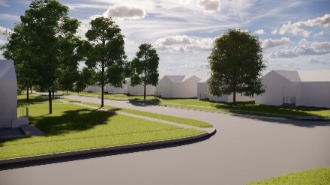
- Which of the following images (Letter) would you prefer your neighborhood to look like? (select one choice) (n=364)

My neighborhood doesn’t have trees.
(A)
(B)
(C)
(D)
(E)
(F)

Circle the letter represents your image A | B | C | D | E | F

Ranking | Number | Percent
A (~10%) | 3 | 0.8
B (~30%) | 24 | 6.6
C (~50%) | 102 | 28.1
D (~70%) | 89 | 24.5
E (~90%) | 145 | 39.9
F (~0%) | 0 | 0.0

- Since moving to my neighborhood, the tree cover/shade has ______. (select one choice) (n=366)

Ranking | Number | Percent
Decreased | 60 | 16.8
Stayed the same | 149 | 41.6
Increased | 157 | 42.9

- When I look out of the windows of my home, I see ______________. (select one choice) (n=366)

Ranking | Number | Percent
No trees (0) | 5 | 1.4
A few trees (1-2) | 49 | 13.4
Several trees (3-7) | 101 | 27.6
Many trees (7-11) | 118 | 32.2
A forest/woodland environment (12 or more trees) | 93 | 25.4

- How much time does it take to walk from your home to the nearest park, green space, or natural area? (n=356)

_________ Minutes

Median = 5, Mean 5.49, Standard Error Mean 0.33, Range 0 to 60
74.3% of respondents live within 5 minutes of park, green space, or natural area

- How frequently do you visit/recreate in this park, green space, or natural area? (select one choice) (n=364)

Ranking | Number | Percent
Daily | 167 | 45.9
Weekly | 131 | 36.0
Once a month | 31 | 8.5
Several times a year | 19 | 5.2
Once a year | 6 | 1.6
Never | 7 | 1.9
Not applicable | 3 | 0.8

- What, if any, are the top benefits you associate with trees in your community or neighborhood? List up to three benefits. (n=344 respondents, 939 keywords)
Keyword | Number | Percent of Keywords | Percent of Respondents
Aesthetics | 172 | 18.3 | 50.0
Calming | 39 | 4.2 | 11.3
Cooling | 55 | 5.9 | 16.0
Environmental | 129 | 13.7 | 37.5
Monetary | 19 | 2.0 | 5.5
Nature | 24 | 2.6 | 7.0
Noise Reduction | 29 | 3.1 | 8.4
Other | 44 | 4.7 | 12.8
Privacy | 40 | 4.3 | 11.6
Shade | 203 | 21.6 | 59.0
Wildlife | 165 | 17.6 | 48.0
Wind Reduction | 20 | 2.1 | 5.8
- What, if any, are the drawbacks associated with the trees in your community or neighborhood? List up to three drawbacks. (n=310 respondents, 412 keywords)
Keyword | Number | Percent of Keywords | Percent of Respondents
Comment | 17 | 4.1 | 5.5
Cost | 14 | 3.4 | 4.5
Damage to Property | 31 | 7.5 | 10.0
Debris (Falling branches/trees) | 27 | 6.6 | 8.7
Debris (Fruit) | 21 | 5.1 | 6.8
Debris (Leaves) | 77 | 18.7 | 24.8
Insects & disease | 14 | 3.4 | 4.5
Invasive Species | 10 | 2.4 | 3.2
Maintenance | 48 | 11.7 | 15.5
None | 60 | 14.6 | 19.4
Obstruction | 16 | 3.9 | 5.2
Other | 66 | 16.0 | 21.3
Tree selection | 11 | 2.7 | 3.5

- Have you ever had a negative experience with a tree? (Check any that apply) (n=356 with n=421 listed negative experiences)

Selected Choice | Number | Percent of Total | Percent of Respondents
No negative experience | 185 | 43.9 | 52.0
Growing into and damaging your property | 37 | 8.8 | 0.1
Causing injury after losing a branch or tipping over | 13 | 3.1 | 3.7
Requiring costly maintenance or removal | 141 | 33.5 | 39.6
Preventing you from developing your property given local protections | 3 | 0.7 | 0.8
Causing issues when obtaining a new home insurance policy | 2 | 0.5 | 0.6
Other | 40 | 9.5 | 11.2

- Given the choice to select from the following topical areas, please rate the importance to you. (n=356 to 363)
(check the appropriate response)

 | Very Unimportant (1) | Unimportant (2) | Neither Unimportant or Important (3) | Important (4) | Very Important (5) | Index Score
Sunlight access for solar PV electrical panels | 14.6 | 14.9 | 32.9 | 28.7 | 9.0 | 3.0
Tree planting agreements on private property | 15.0 | 11.7 | 31.5 | 30.4 | 11.4 | 3.1
Sidewalks on both sides of the street | 26.2 | 14.9 | 20.4 | 24.0 | 14.6 | 2.9
Shade from tree canopy | 0.3 | 0.3 | 4.7 | 35.3 | 59.4 | 4.5
- Please rate the importance to you of the following economic, social and environmental benefits provided by public trees? (public trees are those along the street ROW, in medians, in parks, and on other public properties) (n=356 to 361)

(check the appropriate response)

 | Very Unimportant (1) | Unimportant (2) | Neither Unimportant or Important (3) | Important  (4) | Very Important  (5) | Index  Score
Increase property values by improving the curb appeal of the neighborhood | 3.3 | 2.8 | 9.7 | 38.1 | 46.1 | 4.2
Reduce cooling and heating costs | 1.9 | 0.3 | 7.8 | 29.1 | 60.9 | 4.5
Trees in business and commercial districts attract visitors/customers | 3.0 | 4.4 | 18.3 | 39.6 | 34.6 | 4.0
Visual beauty | 1.7 | 0.0 | 1.9 | 25.2 | 71.2 | 4.6
Visual buffer between pedestrians and streets | 1.9 | 4.5 | 18.1 | 32.0 | 43.5 | 4.1
Provide sense of place to neighborhood and community | 1.7 | 0.8 | 8.7 | 30.4 | 58.4 | 4.4
Calm and reduce traffic speed | 2.8 | 3.9 | 20.8 | 32.6 | 39.9 | 4.0
Reduce crime levels | 12.8 | 7.8 | 34.1 | 23.5 | 21.8 | 3.3
Reduce stress and improve mood | 1.7 | 0.6 | 5.6 | 25.4 | 66.8 | 4.6
Provide nesting habitat and food sources for butterflies, birds, bees, and other wildlife | 1.4 | 1.4 | 3.0 | 18.6 | 75.6 | 4.7
Reduce noise pollution | 1.4 | 0.6 | 6.1 | 25.9 | 66.0 | 4.5
Reduce levels of particulate matter and other air pollutants | 1.4 | 0.6 | 4.8 | 19.1 | 74.2 | 4.6
Reduce global warming gases, like carbon dioxide | 2.2 | 0.6 | 3.9 | 14.5 | 78.8 | 4.7
Reduce soil erosion caused by stormwater | 1.4 | 0.0 | 3.3 | 24.5 | 70.8 | 4.6
Roots filter out pollutants and protect groundwater | 1.1 | 0.6 | 4.2 | 24.0 | 70.2 | 4.6
Cooling effect on heat from asphalt and buildings | 1.1 | 0.6 | 4.7 | 21.4 | 72.1 | 4.6

Management of Trees

- The trees on my street are? (select one choice) (n=364)

Ranking | Number | Percent
Not cared for | 43 | 11.8
Adequately cared for | 240 | 65.9
Well cared for | 81 | 22.3

- What, if any, things could be improved about the City of Fitchburg’s public trees? List up to three things (public trees are those along the street ROW, in medians, in parks, and on other public properties) (n=251 respondents, 426 keywords)

Keyword | Number | Percent of Keywords | Percent of Respondents
Comment | 46 | 10.8 | 18.3
Invasive | 9 | 2.1 | 3.6
Maintenance | 98 | 23.0 | 39.0
Other | 46 | 10.8 | 18.3
Planting | 103 | 24.2 | 41.0
Preservation | 43 | 10.1 | 17.1
Selection | 81 | 19.0 | 32.3

- The visual diversity of trees on my street is? (select one choice) (n=363)

Category | Number | Percent
Not enough | 101 | 27.8
Enough | 261 | 71.9
Too much | 1 | 0.3

- I would like to see the following in my park or on my street? (Check all that apply) (n=355)
Category | Number | Percent of Total | Percent of Respondents
Edible fruit and nut trees | 133 | 7.7 | 37.5
Evergreen trees (like pine or spruce) | 175 | 10.1 | 49.3
Fall colors | 259 | 14.9 | 73.0
Flowering trees (like cherry or redbud) | 227 | 13.1 | 63.9
More uniformity of trees | 7 | 0.4 | 2.0
More variety of trees | 180 | 10.4 | 50.7
Native plants/trees | 214 | 12.3 | 60.3
Prairie/tall grass areas | 142 | 8.2 | 40.0
Shade Trees | 286 | 16.5 | 80.6
Shrubs | 110 | 6.3 | 31.0
- How strongly would you support or oppose restoration and maintenance of native trees on public lands? (select one choice) (n=360)

Category | Number | Percent
Strongly Oppose (-2) | 50 | 13.9
Oppose (-1) | 7 | 1.9
Neither Support nor Oppose (0) | 26 | 7.2
Support (1) | 94 | 26.1
Strongly Support (2) | 183 | 50.8

- Which of the following would be your first choice of where the city should plant trees?? (select one choice) (n=337)

Category | Number | Percent
Along streets | 153 | 45.4
Along rural right-of-ways | 6 | 1.8
In commercial/industrial areas | 29 | 8.6
In parks | 117 | 34.7
In people's yards | 14 | 4.2
Near streams, natural and/or forested areas | 18 | 5.3

- Which of the following statements most closely represents your opinion about trees? (select one choice) (n=363)

Category | Number | Percent
Allow individuals to remove trees as they wish | 22 | 6.1
Preserve as many as possible | 149 | 41.0
Preserve only large or unique trees | 23 | 6.3
When trees are removed, replace them | 141 | 38.8
Other | 28 | 7.7

- Would you plant trees on your property if offered a monetary incentive? (select one choice) (n=365)

Category | Number | Percent
Yes | 208 | 57.0
No | 15 | 4.1
Need more information | 106 | 29.0
Not applicable | 36 | 9.9

- How much would you be willing to pay in additional annual property taxes to better maintain and protect existing city trees? (select one choice) (n=363)

Amount ($) | Number | Percent
0 | 85 | 23.4
2 | 21 | 5.8
6 | 5 | 1.4
10 | 44 | 12.1
14 | 3 | 0.8
20 | 53 | 14.6
30 | 21 | 5.8
40 | 96 | 26.4
Other | 35 | 9.6

Median $20, Mean $22.24, $1.82 Std Error Mean, Range $0 to $500

- How strongly would you support or oppose removal of invasive shrubs on City property? (select one choice) (n=362)

Category | Number | Percent
Strongly Oppose (-2) | 50 | 13.8
Oppose (-1) | 10 | 2.8
Neither Support nor Oppose (0) | 22 | 6.1
Support (1) | 93 | 25.7
Strongly Support (2) | 187 | 51.7

- Which of the following statements most closely represents your opinion about managing trees in public parks / woodlots? (select one choice) (n=363)

Category | Number | Percent
Allow all trees and shrubs to grow with little to no management | 51 | 14.0
Remove invasive shrubs | 42 | 11.6
Remove invasive shrubs and replace them with native trees and shrubs | 252 | 69.4
Clear these areas of trees in favor of athletic fields | 0 | 0.0
Other | 18 | 5.0

- Which of the following would be your first choice of how the City should manage woodlots? (select one choice) (n=339)

Category | Number | Percent
Leave them alone and let nature take over | 66 | 18.4
Remove invasive species and plant native trees and shrubs | 224 | 62.4
Restore oak savanna | 49 | 13.6
Comments of paper survey | 20 | 5.6

Demographic Information

- Which best explains your connection to the City of Fitchburg? (select one choice) (n=358)

Category | Number | Percent
Live here | 281 | 78.5
Work here | 5 | 1.4
Live and work here | 70 | 19.6
Don't live or work here | 2 | 0.6

- How many years have you lived in your current neighborhood ___________? (Fill in the blank) (n=337)

_________ Years (mean = 15.9, Std. Error Mean = 0.76)

Category | Number | Percent
Less than 3 years | 36 | 10.7
3 to 5 years | 50 | 14.8
6 to 10 years | 83 | 24.6
11 to 20 years | 55 | 16.3
21 years or more | 113 | 33.5

- If you live in the City of Fitchburg, in which neighborhood do you live? See neighborhood map (below) to answer. (n=336)

Neighborhood |  | Number | Percent
Braeger Court |  | 0 | 0.0
Briarwood |  | 0 | 0.0
Byrnewood |  | 14 | 4.2
Chapel Valley |  | 2 | 0.6
Country Heights |  | 0 | 0.0
Country Vineyard |  | 1 | 0.3
Crescent Crossing |  | 6 | 1.8
Dunn's Marsh |  | 3 | 0.9
East Fitchburg |  | 21 | 6.3
Fahey Fields |  | 8 | 2.4
Forsythe Downs |  | 0 | 0.0
Greenfield |  | 17 | 5.1
Harlan Hills |  | 2 | 0.6
Hatchery Hill |  | 1 | 0.3
Highfield Reserve |  | 3 | 0.9
Highlands of Seminole |  | 20 | 6.0
Hillside Heights |  | 0 | 0.0
Jamestown |  | 2 | 0.6
Lacy Heights |  | 7 | 2.1
Leopold |  | 1 | 0.3
Maple Lawn heights |  | 0 | 0.0
Mickelson's Woods |  | 7 | 2.1
Morning Sun |  | 0 | 0.0
Nakoma Heights |  | 0 | 0.0
Neighborhood |  | Number | Percent
Nesbitt Heights |  | 0 | 0.0
Nine Springs |  | 2 | 0.6
Northeast Fitchburg |  | 0 | 0.0
Oak Meadow |  | 17 | 5.1
Pine Ridge |  | 0 | 0.0
Quarry Hill |  | 14 | 4.2
Quarry Vista |  | 2 | 0.6
Seminole Forest |  | 24 | 7.1
Seminole Hills |  | 9 | 2.7
Seminole Ridge |  | 15 | 4.5
Southdale |  | 0 | 0.0
Sterling Meadows |  | 4 | 1.2
Stoner Prairie |  | 4 | 1.2
Swan Creek |  | 34 | 10.1
Terravessa |  | 10 | 3.0
Timber Lake Knolls |  | 0 | 0.0
Tower Hill |  | 13 | 3.9
Uptown Crossing |  | 1 | 0.3
Western Hills |  | 0 | 0.0
Waterford Glen |  | 3 | 0.9
Wildwood |  | 19 | 5.7
Wildwood South |  | 11 | 3.3
Willow Run |  | 0 | 0.0
Other |  | 39 | 11.6

- Which of the following best describes your housing type? (select all that apply) (n=335)

Category | Number | Percent
Apartment | 16 | 4.8
Duplex | 6 | 1.8
Condominium | 30 | 9.0
Group home | 0 | 0.0
Mobile home | 0 | 0.0
Single Family Housing | 282 | 84.2
Unhoused | 1 | 0.3
Other | 0 | 0.0

- Which of the following best describes your current housing situation? (select all that apply) (n=334)

Category | Number | Percent
Own | 311 | 93.1
Rent | 19 | 5.7
Living with others but not paying rent | 3 | 0.9
Living with others but assisting with paying rent | 1 | 0.3

- Which of the following identities best describes you? (select all that apply) (n=351)

Category | Number | Percent
American Indian | 2 | 0.6
Asian | 4 | 1.1
African American or Black | 2 | 0.6
Hispanic, Latinx, or Spanish Origin | 9 | 2.6
Native Hawaiian or Pacific Islander | 0 | 0.0
White or Caucasian | 280 | 79.8
Prefer not to say | 46 | 13.1
Two or More Races | 8 | 2.3

- What is your age group? (n=334)

Category | Number | Percent
Under 18 | 3 | 0.9
18-24 | 7 | 2.1
25-34 | 34 | 10.2
35-44 | 79 | 23.7
45-54 | 39 | 11.7
55-64 | 54 | 16.2
65+ | 118 | 35.3

- What is the highest level of education you have attained? (n=337)

Category | Number | Percent
No high school diploma | 2 | 0.6
High school diploma or equivalent (GED) | 3 | 0.9
Some college but no degree | 20 | 5.9
Associate degree | 21 | 6.2
Bachelor degree | 131 | 38.9
Graduate degree | 160 | 47.5

Thank you so much for completing this survey. You may return it through any of these:

Bring or mail to City of Fitchburg | City Hall | 5520 Lacy Road | Fitchburg, WI 53711

Rich Hauer | Eocene Environmental Group | 1420 Sand Hill Lane | Stevens Point, WI 54481

