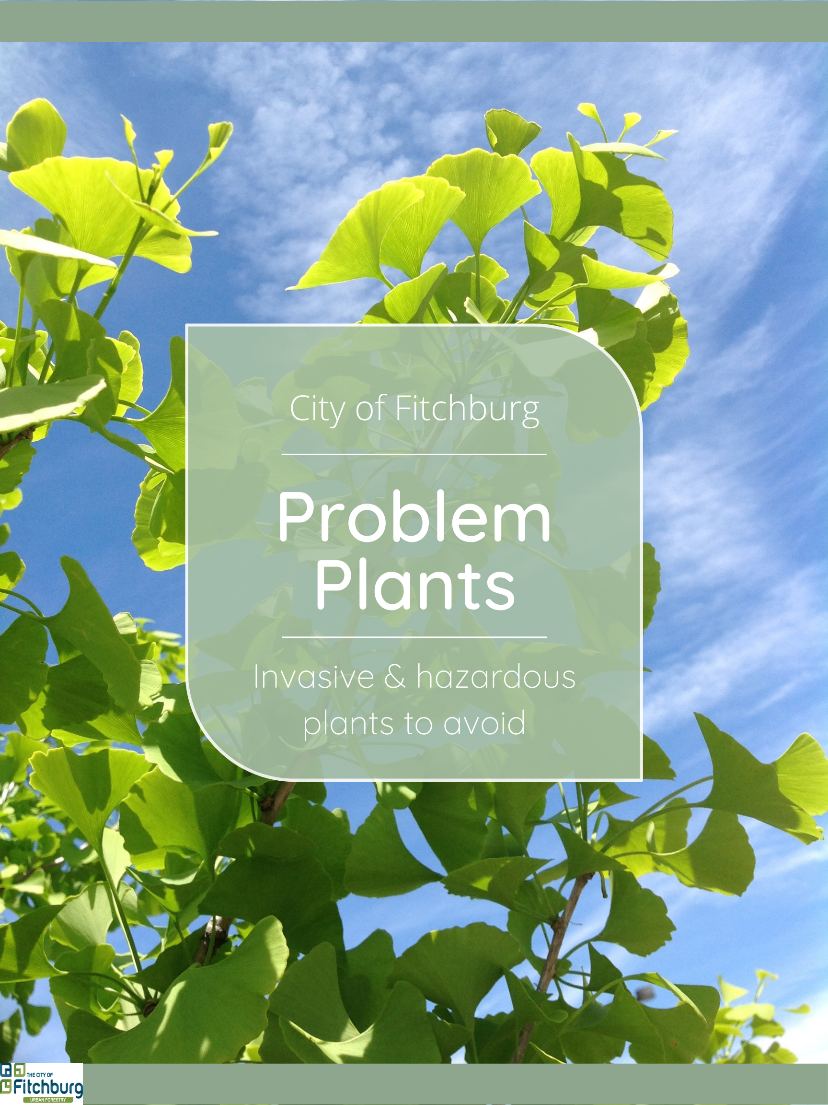
Problem Trees & Shrubs

The following are trees and shrubs that are prohibited or should be avoided in street applications, park settings, and urban yards. They can become a nuisance or even hazardous as they mature due to poor growth form, weak wood and branch attachments, fruit and or seed pods and associated pests and disease issues. They can outcompete native vegetation and become invasive, taking over woodlots, yards, and open areas.

Prohibited Trees

The following trees are prohibited from being planted in street applications, park settings and urban yards in the City of Fitchburg. Trees classified as prohibited shall be removed when practical.

Acer negundo -- Boxelder
Native; weak wood and branch attachments are subject to storm damage; trees can be high maintenance due to drooping branches and poor growth form; attract Box Elder bugs which can be a nuisance.

Phellodendron amurense ‘Macho’ -- Macho amur corktree
Non-native, introduced from eastern Asia around the 1850’s; allelopathic, exuding chemicals from the roots which impact soil microorangisms and surrounding vegetation; tolerates a wide variety of sire and soil conditions; prolific seed producers and stump sprouters.

Populus deltoids -- Cottonwood
Native; susceptible to storm damage due to shallow root system and weak wood and branch attachments; female cottonwoods produce large numbers of cottony seeds which litter the landscape.

Trees to Avoid

The following trees should be avoided when planting in street applications, park settings and urban yards in the City of Fitchburg.

Acer ginnala -- Amur maple
Non-native, imported from Asia for ornamental purposes in the 1860’s; invades open grasslands, prairies and forests; outcompetes native vegetation reducing overall biodiversity.

Acer platanoides -- Norway maple
Non-native, has escaped urban environment and now poses a threat to our native maple species; aggressive roots frequently result in self-girdling; shallow, fibrous root system prevents grass from growing under the tree and is susceptible to being blown over in windy, wet environments.

Acer saccharinum -- Silver maple
Native; subject to branch breakage following ice storms; aggressive roots can clog drains and buckle sidewalks; susceptible to wood and root decay; trees can be high maintenance due to poor growth form.

Fraxinus spp. -- Ash species
Although they are well suited for street terraces, all ash native to North America are susceptible to the Emerald Ash Borer (EAB). This beetle attacks and kills ash trees indiscriminately. Therefore, continued planting of ash trees is discouraged.

Populus spp. -- Poplars/aspen species
Poplar/aspen trees are subject to canker and prone to branch failure in cold snowy climates like Wisconsin; trees are very short lived and have a poor growth form.

Robinia pseudoacacia -- Black locust
Invade forests, prairies, old fields and roadsides; vegetative reproduction forms groves of clones excluding native vegetation; vigorous sprouting, root suckering and lateral spread caused by damage to roots or stems making it difficult to control.

Salix spp. -- Willow species
Willow trees are extremely fast-growing and quickly expand beyond their growing space; roots can interfere with water and sewer lines; weak wood is subject to storm damage and branch failure in high winds and heavy snow loads.

Ulmus pumila -- Siberian elm
Non-native, introduced from Asia in the 1860’s; tolerates a wide variety of growing/site conditions; seeds develop and germinate quickly allowing dense stands to form rapidly and outcompete native vegetation; reduces forage for native fauna.

Pyrus calleryana ‘Bradford’ -- Callery pear ‘Bradford’
This cultivar of callery pear should be avoided due to poor branching structure. The narrow crotches make this tree susceptible to storm damage.

Prohibited Shrubs

The following shrubs are prohibited from being planted in street applications, park settings and urban yards in the City of Fitchburg. Shrubs classified as prohibited shall be removed when practical.

Rhamnus cathartica and Frangula alnus -- Common buckthorn and Glossy buckthorn
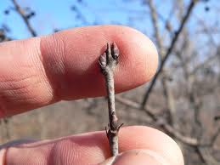
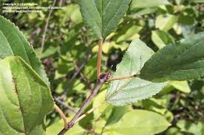
Non-natives; tolerate a wide variety of site conditions; leaf-out early and retain leaves late into season allowing for a longer growing season than native vegetation; shades out regeneration of native tree and shrub species; can quickly take over the understory of woodlots.
Buckthorn Shrub

Shrubs to Avoid

The following shrubs should be avoided when planting in street applications, park settings and urban yards in the City of Fitchburg.

Lonicera spp. -- Honeysuckle species
Non-native species include Japanese honeysuckle, Morrow’s honeysuckle, Tatarian honeysuckle, Bell’s honeysuckle and Amur honeysuckle; outcompete native vegetation; will take over prairies, forests, fields and roadsides.
The only honeysuckle native to Wisconsin is the American fly honeysuckle (Lonicera Canadensis).

Euonymus alatus -- Burning bush
Non-native, introduced from Asia in the 1860’s as an ornamental; tolerates a wide variety of site and soil conditions; produces large amounts of seed; non-palatable to deer, giving it a competitive advantage over native vegetation.

Berberis thunbergii -- Japanese barberry
Non-native, introduced from Japan in 1875 as an ornamental; tolerates a wide variety of site and environmental conditions; spines deter deer browse giving it an advantage over native vegetation; spreading horizontal branches will root freely when they touch the ground leading to dense thickets; research has shown higher rates of Lyme disease carrying ticks in forests infested with this plant.

Rosa multiflora -- Multiflora rose
Non-native, introduced from Japan in 1886 to be used as root stock for cultivated roses; produces up to 500,000 seeds/year that remain viable in the soil for 10 to 20 years; tolerates a wide variety of site conditions; can form dense thickets that exclude native vegetation.

Elaeagnus umbellate -- Autumn olive
Non-native, introduced from Asia; invades open and forested areas; produces numerous fruits in high light conditions; alters nutrient cycling by adding nitrogen to the soil.

Elaeagnus angustifolia -- Russian olive
Non-native, introduced from southern Europe and western Asia; invades open areas, including wet areas; can dry up riparian areas as it uses more water than native species; alters nutrient cycling by adding nitrogen to the soil.

Additional Problem Plant Resources:

- Invasive species - Wisconsin DNR
- Invasive Species Photo Gallery - Wisconsin DNR
- Aquatic Invasive Species - River Alliance of WI (wisconsinrivers.org)

